<http://geosig.hidrografico.pt/flexviewers/ICENC/>

Brief instructions how to use the current WebGIS:

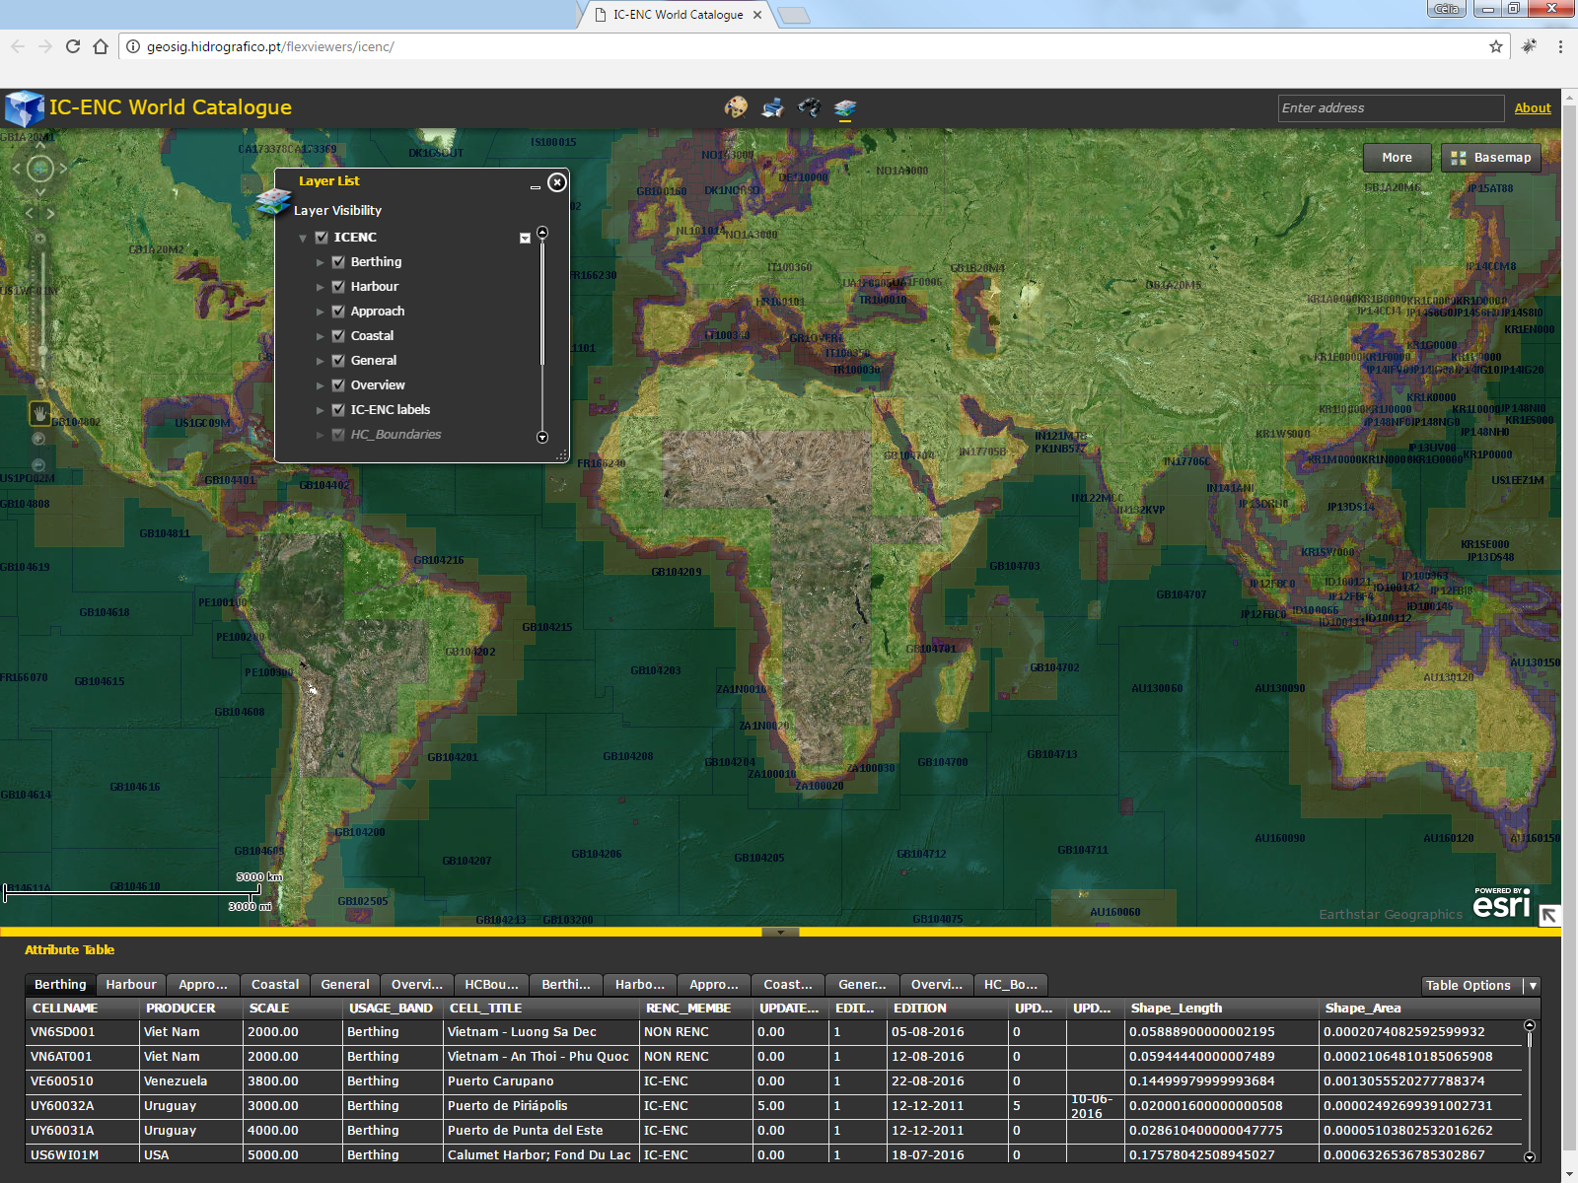

The Layer List Tool 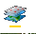

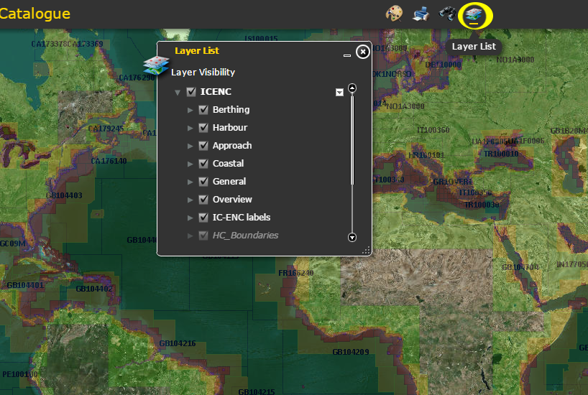

The Layer List enable to select the layers visibility in the map. The selected layers in the list are also displayed at the Attribute Table:

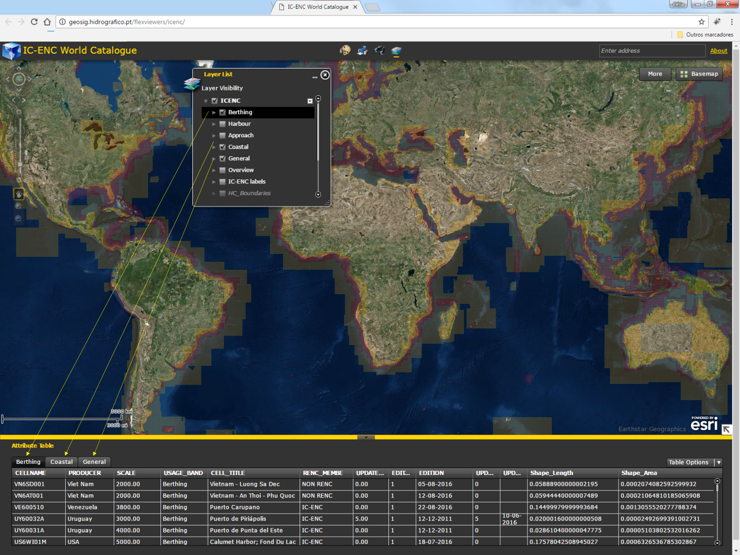

The IC-ENC labels are available in the layer “IC-ENC labels”. 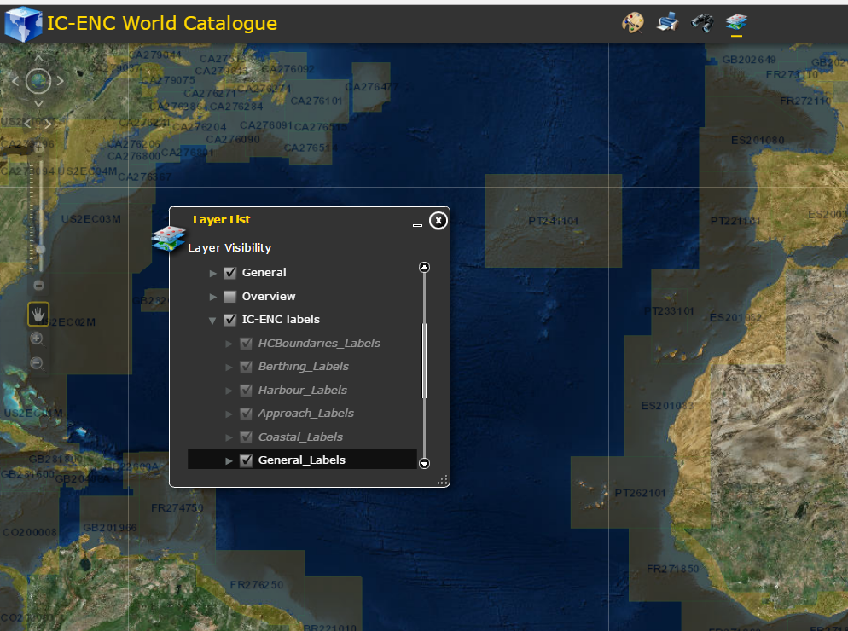

More… tool:

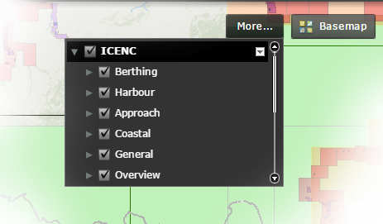

As the Layer Tool List, with this tool, you can also select the layer to display on the map, expand each layer to display the symbology.

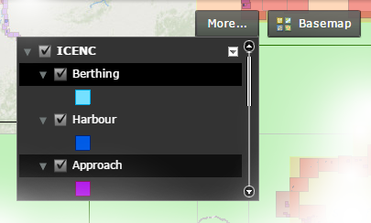

Now, there are some others options to be taken into account by clicking on the small arrow at the right top corner of this toolbox:

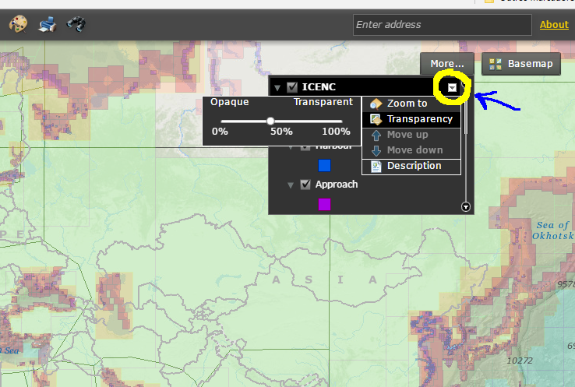

From here you can select the transparency percentage to apply to the selected layers and you can to access to the layers description file:

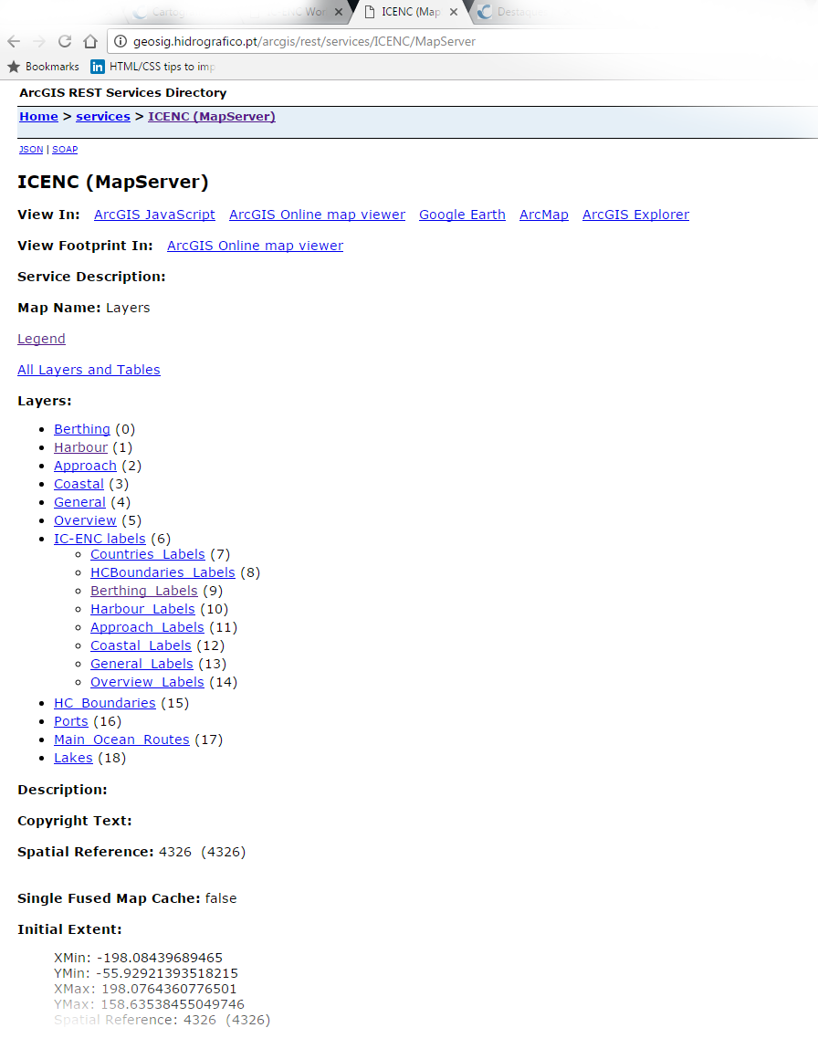

There is also a possibility to choose the base map theme at the Base map box:

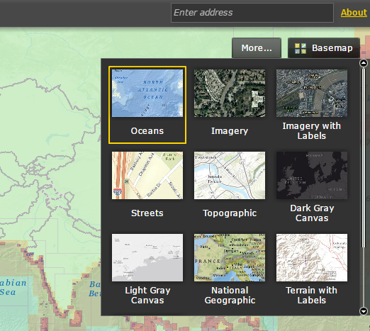

The Oceans theme is presented by default.

The search tool is presented at the top center of the map:

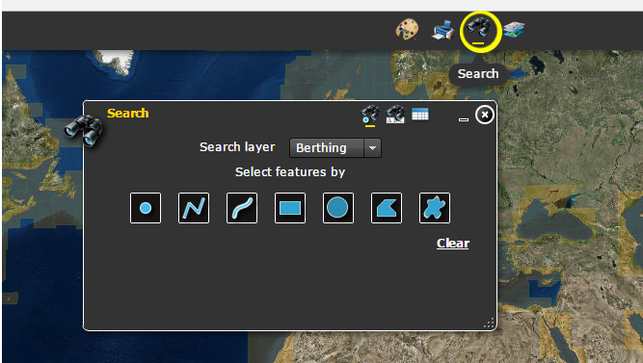

This toolbox only allows to search on the map one layer at the time. The layer can be searched by feature using the tolls available: draw point, draw line, draw freehand line, draw rectangle, draw circle, draw polygon, draw freehand polygon:

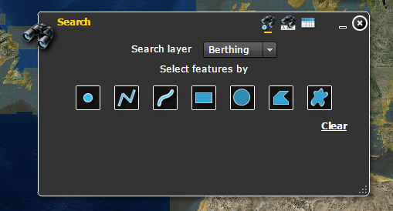

Or can be selected by attribute:

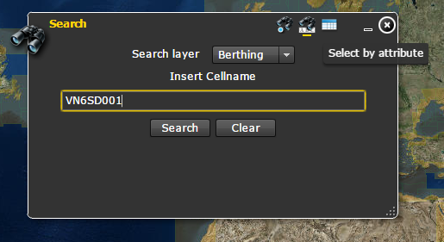

The results are displayed in the map:

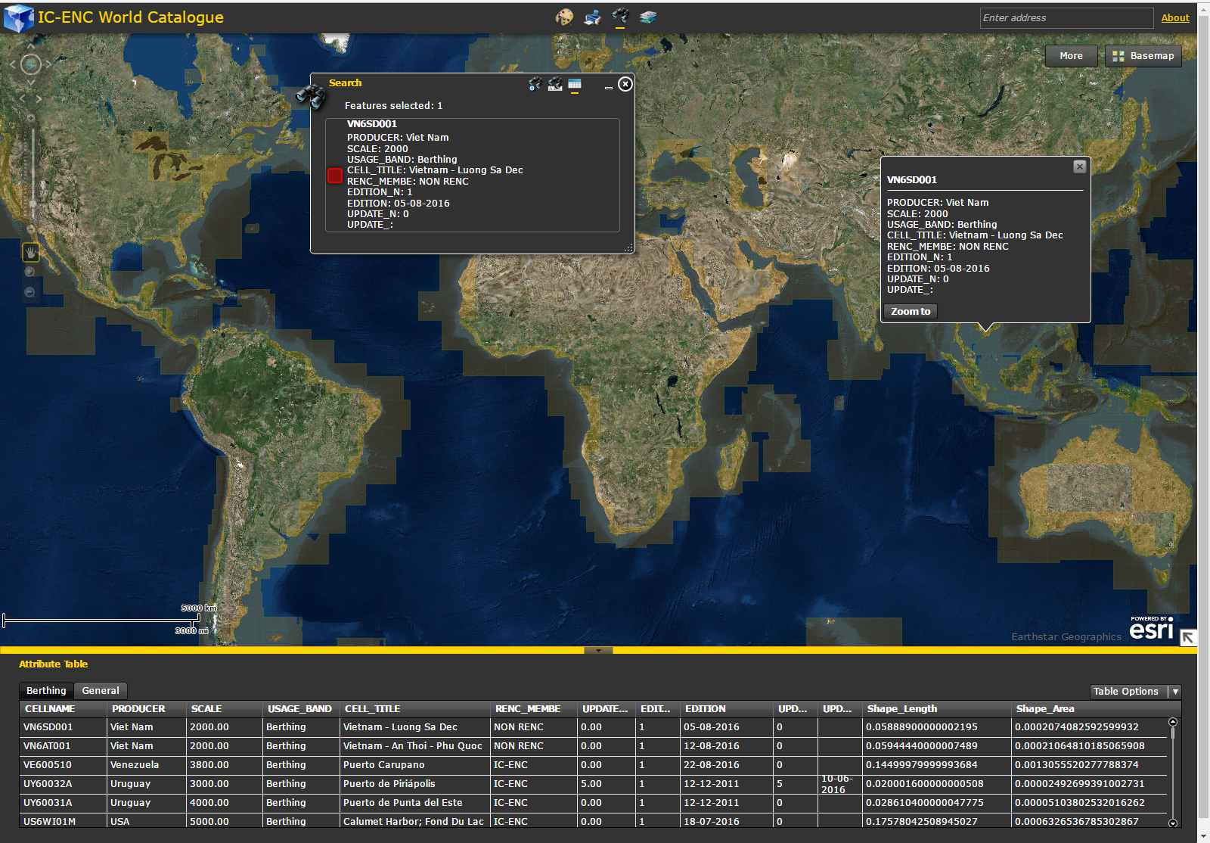

When the results are selected and zoomed, the Attribute Table displays the features layers visible in the map zoomed area:

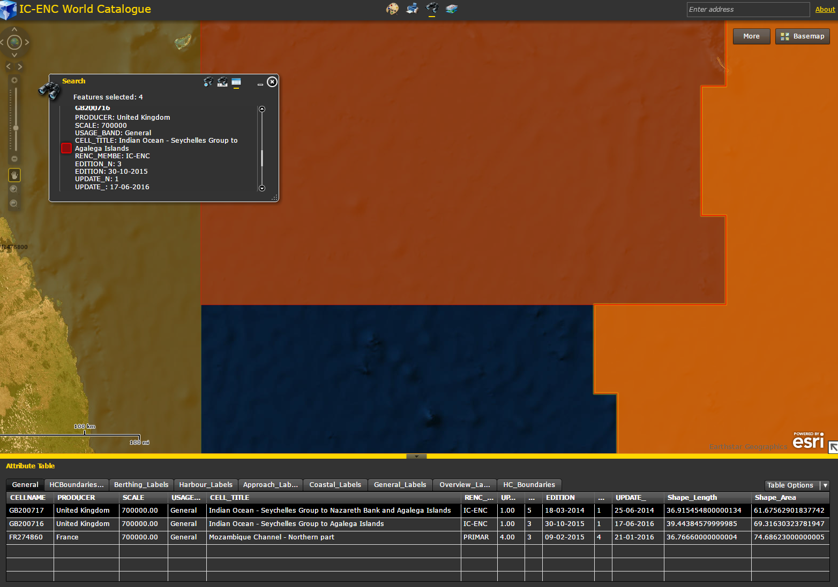

The layers can also be selected using the Attribute Table. As mentioned before, to display the layers in the Attribute Table they must be selected (visible) in the layers List toolbox:

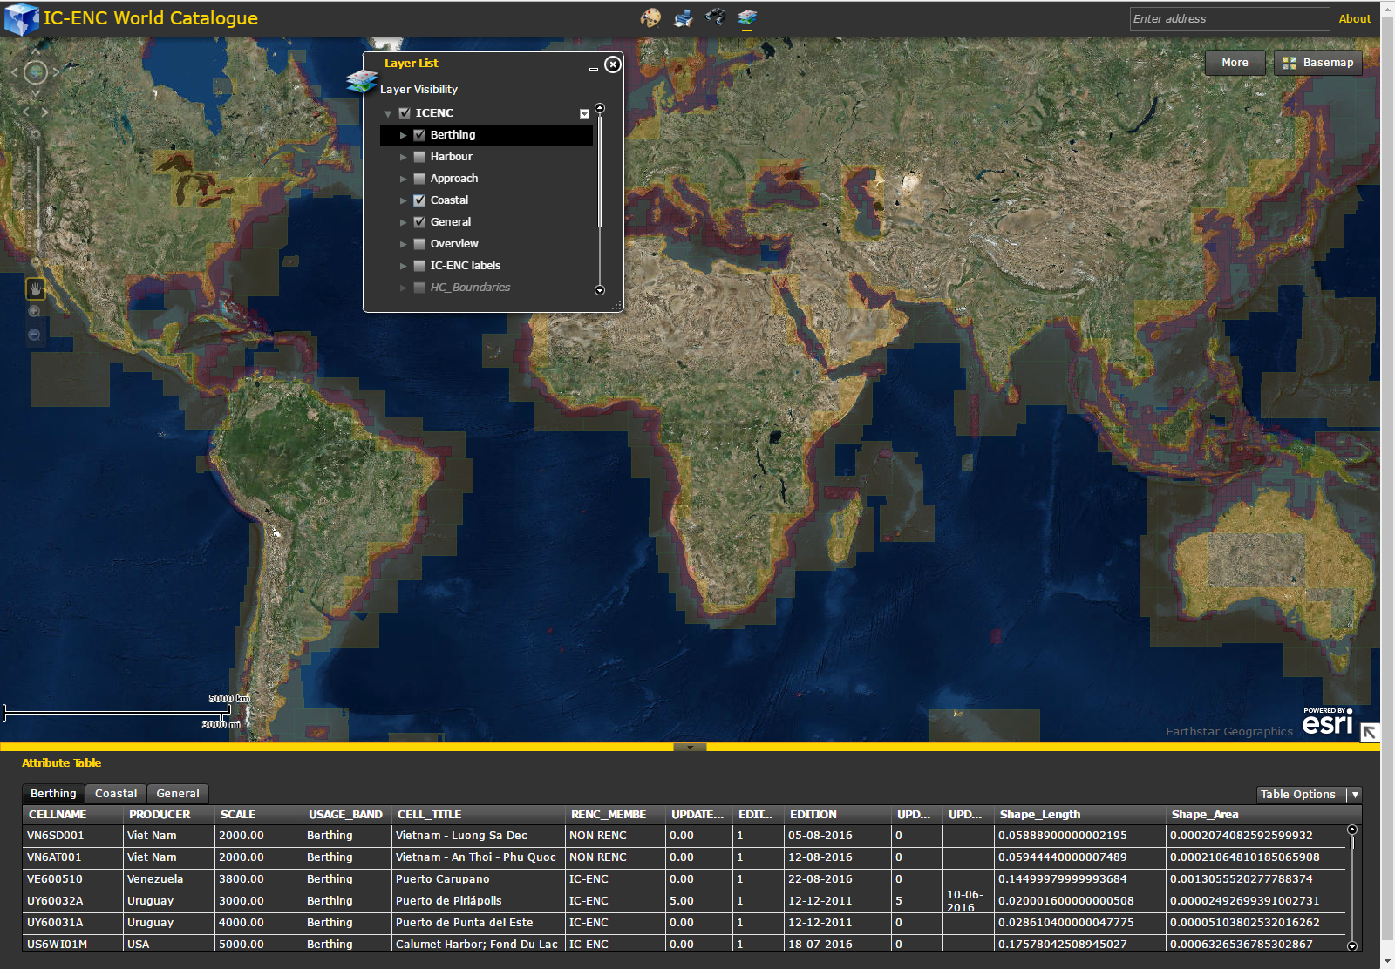

In the Attribute Table, on selecting one layer row, the selected results can be exported into a CSV file and can be zoomed in the map. This options are available at the “Table Options”.

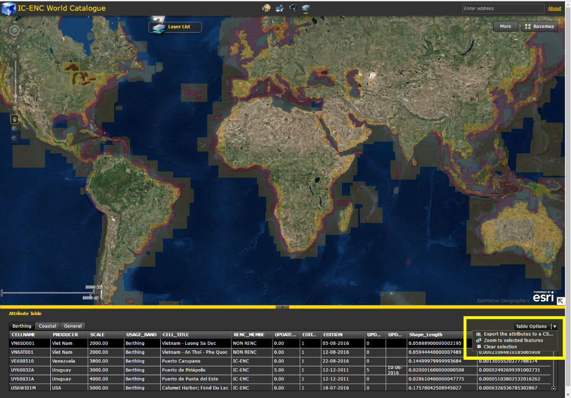

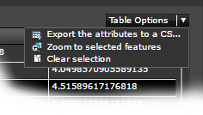

At the up left area of the map there are a few tools for the map display (Full Extent, Pan: up, down, left, right, Zoom in, Zoom out, Next Extent, Previous Extent).

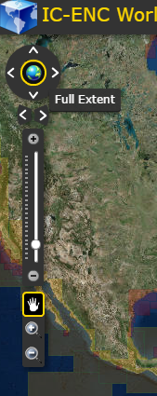

The Draw toolbox is also available with different types of draw forms, text formats and area measurements:

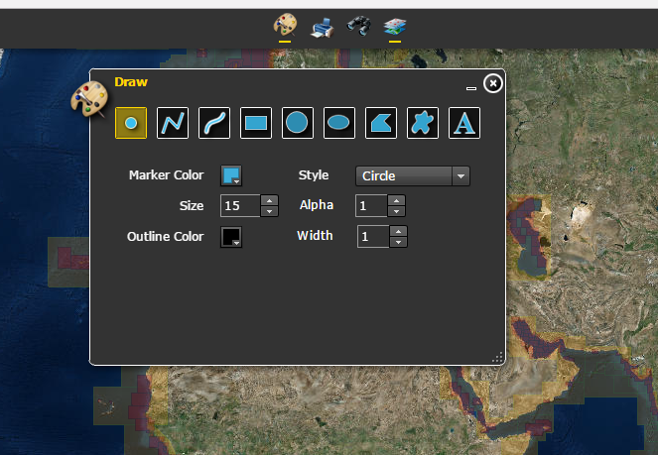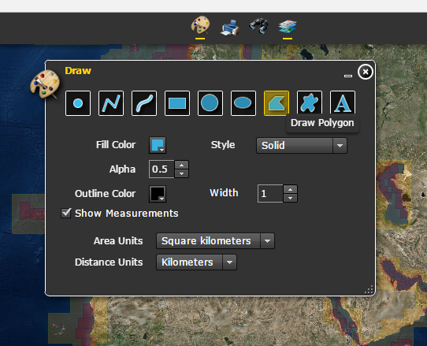

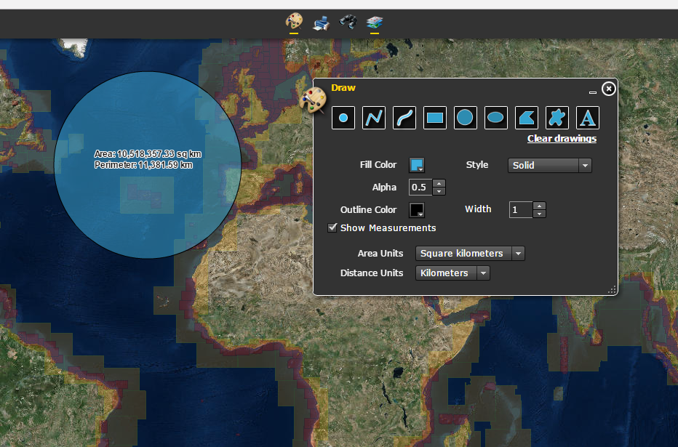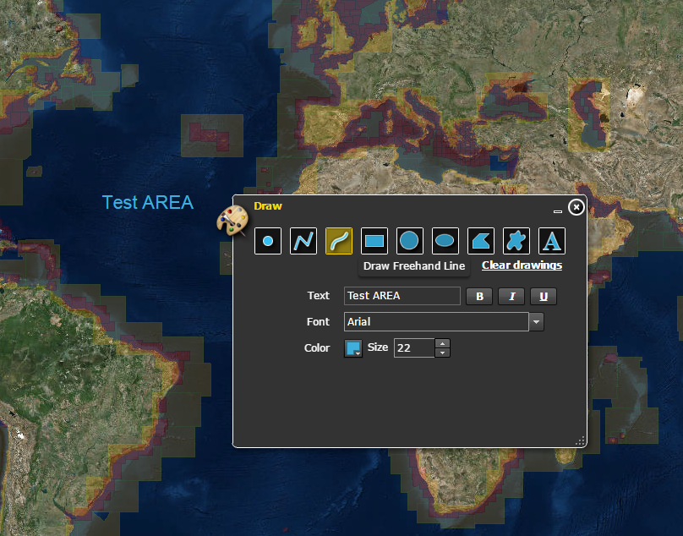

To print a Map onclick the Print tool:

